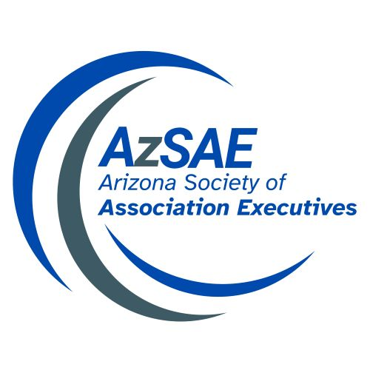

2026 Executive Getaway
August 2-4 - Prescott, Arizona

SPONSORSHIP OPPORTUNITIES

□Gold Level: $1,500 and above
The Gold Sponsorship Level includes one Getaway registration. An opportunity to have a table display at the function you are hosting, company name and logo on all printed material, company name and logo on AZSAE website, company name and logo on all signage, recognition during the Getaway, recognition through social media and the opportunity to supply items for the attendee bags. Sponsor responsible for own hotel accommodations for event.

Check mark area you would like to sponsor:
Sunday Dinner SOLD Tuesday Breakfast Event Photographer
Monday Breakfast SOLD Tuesday To Go Snack Bags
Monday Food Trucks (lunch)
Monday Dinner SOLD

□Silver Level: $750
The Silver Sponsorship Level includes one Getaway registration. Company name and logo on all printed material, company name and logo on AzSAE website, company name and logo on all signage, recognition during the Getaway, recognition through social media and the opportunity to supply items for the attendee bags. Sponsor responsible for own hotel accommodations for event.

□Bronze Level: $250
The Bronze Sponsorship Level includes recognition on website, recognition during the Getaway, recognition on printed program and the opportunity to supply items for the attendee bags.

Deadline – July 17, 2026

2026 AZSAE Getaway
Sponsor Registration

YES! Count us in as a Sponsor!
Sponsorship Level □ Gold □ Silver □ Bronze

If your sponsorship includes event registration:

Registrant Name: Company:

Phone: E-Mail:

Mailing Address:

□ I would like to purchase ______ RAFFLE TICKETS @ $20.00 each

PAYMENT: □ Check (payable to AzSAE) □ VISA  □ MasterCard  □ American Express

Name: Company:

Phone: E-Mail:

Credit Card #: Exp.: 3-4 digits:

Billing Address:

Authorized Signature:

Please complete the following if your sponsorship level is a Gold or Silver.
Event Registration
□ Yes, I will utilize the event registration benefit to attend each function. Dietary Restriction: _____________________
□  I am only available to attend the event I am hosting Dietary Restriction: _____________________
□ No, I am not able to attend the event, but I am thrilled to be able to serve as a sponsor.

Hotel Reservation – Please send your hotel request information to Karoly (to include name, check in/out dates and room type) Check-in is at 4:00 PM, and check-out is at 11:00 AM. Early check-ins, late check-outs, and extended stays are subject to availability and are not guaranteed. Supplier rate is $130/night. Reservations must be made by July 17th.

□I am local and do not need accommodation.

Mail or email registration form, with payment, to: AZSAE, 4300 N. Miller Rd., #141, Scottsdale, AZ 85251 or info@azsae.org
Questions? Call Karolyn Kiburz 480-946-0119.

